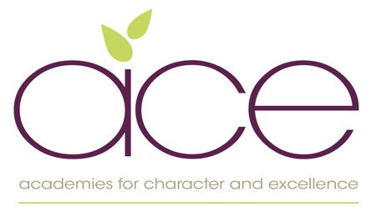
Academies for Character and Excellence

Excellence through Cultivating Character, Sharing Talents and Pursuing Innovation
SENco
Totnes St John’s C of E Primary, Totnes
Payscale – MPS plus SEN allowance
Permanent – 2 days per week (0.4)
(with a possibility of 2 days per week (0.4) at Collaton St Mary C of E Primary)

The Academies for Character and Excellence has seven Primary Schools and three Pre-schools making up a dynamic and innovative learning organisation. We also work in partnership with an eighth school which is due to join us officially later in the Summer term.

We live our mission and return to this constantly to help guide every action. At the heart of all we do is the pursuit of excellence; we want to grow an exceptional trust, comprised of excellent schools. We are achieving this through our shared core values of collaboration, community, Integrity, equity, and of course uncompromising excellence.

We are truly collaborative and we work together within, and across, our schools to ensure that all our children and members of staff achieve their potential. Together we work to create a full and rich curriculum offer allowing everyone to flourish - we translate our vision of excellence into our every-day practice. We are proud of our successful learning outcomes, but we aspire to achieve more than just academic excellence for our children. We also want our children to become healthy thinkers, curious explorers, caring citizens, knowledgeable participants and confident individuals.

We aim to serve our communities, and our schools make every effort to connect with families, local community groups and organisations to ensure that our children and families are nurtured, supported and provided with opportunities through our schools.

Our value of equity leads us to want the very best of every child and every member of staff. The Academy for Character and Excellence believes in ‘Personal Growth for All’ and we are committed to tackle inequalities and overcome disadvantage, and to provide bespoke opportunities for professional learning for all.

We are looking to appoint an exceptional candidate who:
- Has a commitment to an inclusive education for all children
- A sound knowledge of the SEN code of practice and experience of the EHCP process and Early Help services
- Has a ability to positively lead others
- Experience in supporting SEND children and their families
- Can inspire and motivate all children and enable them to be the best that they can be
- To work in partnership with the head teacher, local governing body and the wider community to ensure that our mission and ethos is translated into action.

Whilst the 0.4 post is currently being advertised for Totnes St John’s there is a potential opportunity for a further 2 days at Collaton St Mary. We would therefore welcome candidates for either a 2-day or 4-day preference.

We can offer the candidate:

- An exciting an innovative Trust that will inspire and allow you to reach your full potential
- An exciting new curriculum which develops all children as individuals through inspiring experiences that enable them to develop rich knowledge, alongside meta-cognition skills.
- Collaborative support within Trust Improvement Groups
- Inspirational leadership with support from a Lead Practitioner and an NLE
- A Trust which cultivates pupils through character development leading to a stimulating and innovative curriculum
- Polite, happy and engaged children with a great enthusiasm for learning
- Working with like-minded professionals across the Trust enabling continuous professional support

You will undertake, or already have, the National Award for SENCOs which is a mandatory qualification for the role.
We are committed to safeguarding and promoting the welfare of children and young people and expect all staff and volunteers to share this commitment. An enhanced DBS clearance is required for this post

For further information please email the recruitment team on recruitmetn@acexcellence.co.uk or to arrange an school visit please contact the school office directly on 01803 864695.

An application form is available to download either from Devon Jobs, our website https://www.acexcellence.co.uk/trust-vacancies or by emailing the recruitment team. Applications must be completed and emailed to recruitment@acexcellence.co.uk by 5pm on Sunday 22nd May. Interviews will be held week commencing the 23rd May.

